**AtliQ Mart Supply Chain Insights**

**-------------------------Quantity Metrics KPIs-------------------------**

1. **Total Order Quantity**

SELECT *Sum*(order_qty) AS total_order_quantity

FROM [dbo].[fact_order_lines]

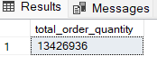

1. **Total Delivery Quantity**

SELECT *Sum*(delivery_qty) AS total_delivery_qty

FROM [dbo].[fact_order_lines]

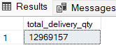

1. **Total Undelivered Quantity**

SELECT *Sum*(order_qty) - *Sum*(delivery_qty) AS undelivered_quantity

FROM [dbo].[fact_order_lines]

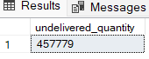

**--------------OTIF, OT, IF, VOFR, LIFR Percentage KPI’s----------**

1. **OTIF (On time in full) Percentage**

SELECT

**Concat**(*Round*((*Cast*((SELECT *Count*(*)

FROM [dbo].[fact_orders_aggregate]

WHERE otif = 'Yes') AS *FLOAT*) / *Cast*((SELECT *Count*(*) FROM [dbo].[fact_orders_aggregate]) AS

*FLOAT*))* 100, 2), '%') AS otif_percentage



1. **OT (On time) Percentage**

SELECT

**Concat**(*Round*(( *Cast*((SELECT *Count*(*)

FROM [dbo].[fact_orders_aggregate]

WHERE on_time = 'Yes') AS *FLOAT*) / *Cast*((SELECT *Count*(*)FROM [dbo].[fact_orders_aggregate]) AS

*FLOAT*)) * 100, 2), '%') AS on_time_percentage



1. **IF (In full) Percentage**

SELECT

Concat(*Round*((*Cast*((SELECT *Count*(*)

FROM [dbo].[fact_orders_aggregate]

WHERE in_full='Yes') AS *FLOAT*) / *Cast(*(SELECT *Count*(*) FROM [dbo].[fact_orders_aggregate]) AS *FLOAT*)) * 100, 2), '%') AS in_full_percentage as float)) * 100, 2), '%') AS on_time_percentage



1. **VOFR (Volume fill rate) Percentage**

SELECT Concat(*Round*(( *Cast*((SELECT *Sum*(delivery_qty)

FROM [dbo].[fact_order_lines])

AS *FLOAT*) / *Cast*((SELECT *Sum*(order_qty)FROM [dbo].[fact_order_lines]) AS *FLOAT*)) * 100, 2), '%') AS vofr_percentage



1. **LIFR (Line fill rate) Percentage**

WITH cte

AS (SELECT *Count*(*) AS total_order_lines,

*Count*(CASE

WHEN f.in_full = 'Yes' THEN 1

ELSE NULL

END) AS fulfilled_order_lines

FROM [dbo].[dim_products] AS d

LEFT JOIN [dbo].[fact_order_lines] AS f

ON d.product_id = f.product_id)

SELECT Concat(*Round*(*Cast*(fulfilled_order_lines AS *FLOAT*) / *Cast*(total_order_lines AS *FLOAT*)* 100, 2), '%') AS LIFR_percentage FROM cte



**---------------------------Customer Matrices-----------------------------**

1. **Total Number of customers**

SELECT *Count*(DISTINCT( customer_name )) AS total_customers

FROM [dbo].[dim_customers]

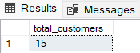

1. **List of all Customers Name in each City**

SELECT city,

**String_agg**(customer_name, ', ') AS list_of_customer_name

FROM [dbo].[dim_customers]

GROUP BY city

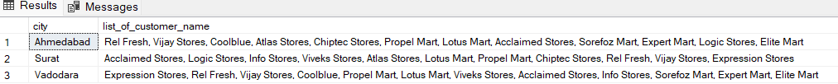

**----------------------------City-wise Matrices-----------------------------**

1. **Total Order Quantity and Total Delivery Quantity by City**

SELECT d.city,

*Sum*(order_qty) AS total_order_quantity,

*Sum*(delivery_qty) AS total_delivery_quantity

FROM [dbo].[fact_order_lines] AS f

LEFT JOIN [dbo].[dim_customers] AS d

ON f.customer_id = d.customer_id

GROUP BY d.city

ORDER BY total_delivery_quantity DESC,

total_order_quantity DESC

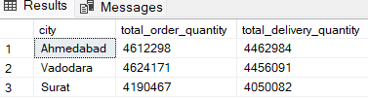

1. **Quantity Ordered V/S Quantity Delivered V/S Undelivered Quantity as per category and product.**

WITH cte

AS (SELECT d.category,

d.product_name,

f.order_qty,

f.delivery_qty

FROM [dbo].[fact_order_lines] AS f

LEFT JOIN [dbo].[dim_products] AS d

ON f.product_id = d.product_id)

SELECT category,

product_name,

*Sum*(order_qty) AS total_order_quanity,

*Sum*(delivery_qty) AS total_delivery_quantity,

*Sum*(order_qty) - *Sum*(delivery_qty) AS quantity_undelivered_as_per_order

FROM cte

GROUP BY category,

product_name

ORDER BY *Sum*(delivery_qty) DESC

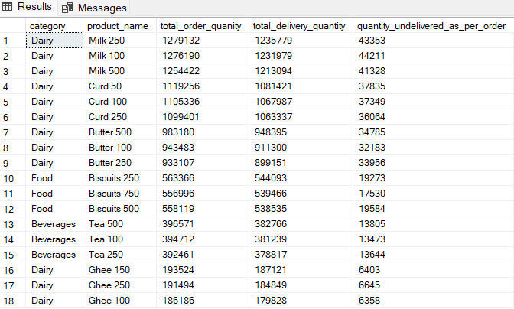

**------------------Customer Performance Metrics--------------------**

1. **List of Customer Name from each City with Highest Delivery Quantity.**

WITH cte

AS (SELECT d.city,

d.customer_name,

f.order_qty,

f.delivery_qty

FROM [dbo].[dim_customers] AS d

LEFT JOIN [dbo].[fact_order_lines] AS f

ON f.customer_id = d.customer_id),

semi_final

AS (SELECT C.city,

C.customer_name,

*Sum*(C.order_qty) AS total_order_qty,

*Sum*(C.delivery_qty) AS total_delivery_qty,

**Dense_rank**()

OVER (

partition BY city

ORDER BY *Sum*(delivery_qty) DESC) AS Ranking

FROM cte AS C

GROUP BY C.city,

C.customer_name)

SELECT city,

customer_name,

total_delivery_qty

FROM semi_final

WHERE ranking = 1

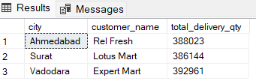

1. **List of Customer Name from each City with Lowest Delivery Quantity.**

WITH cte

AS (SELECT d.city,

d.customer_name,

f.order_qty,

f.delivery_qty

FROM [dbo].[dim_customers] AS d

LEFT JOIN [dbo].[fact_order_lines] AS f

ON f.customer_id = d.customer_id),

semi_final

AS (SELECT C.city,

C.customer_name,

*Sum*(C.order_qty) AS total_order_qty,

*Sum*(C.delivery_qty) AS total_delivery_qty,

**Dense_rank**()

OVER (

partition BY city

ORDER BY *Sum*(delivery_qty) ASC) AS Ranking

FROM cte AS C

GROUP BY C.city,

C.customer_name)

SELECT city,

customer_name,

total_delivery_qty

FROM semi_final

WHERE ranking = 1

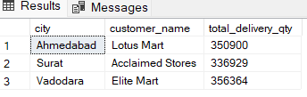

1. **Customer Name from each city which has the highest otif (On-Time-In-Full).**

WITH cte

AS (SELECT d.city,

d.customer_name,

f.on_time,

f.in_full,

f.otif

FROM [dbo].[dim_customers] AS d

LEFT JOIN [dbo].[fact_orders_aggregate] AS f

ON d.customer_id = f.customer_id),

final

AS (SELECT C.city,

C.customer_name,

*Count*(otif) AS total_otif,

**Dense_rank**()

OVER(

partition BY city

ORDER BY *Count*(otif) DESC) AS ranking

FROM cte AS C

WHERE otif = 'Yes'

GROUP BY C.city,

C.customer_name)

SELECT city,

customer_name

FROM final

WHERE ranking = 1

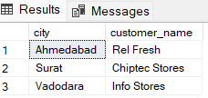

1. **Customer Name from each city which has the lowest otif (On-Time-In-Full).**

WITH cte

AS (SELECT d.city,

d.customer_name,

f.on_time,

f.in_full,

f.otif

FROM [dbo].[dim_customers] AS d

LEFT JOIN [dbo].[fact_orders_aggregate] AS f

ON d.customer_id = f.customer_id),

semi

AS (SELECT C.city,

C.customer_name,

*Count*(otif) AS total_otif,

**Dense_rank**()

OVER(

partition BY city

ORDER BY *Count*(otif) DESC) AS ranking

FROM cte AS C

WHERE otif = 'No'

GROUP BY C.city,

C.customer_name)

SELECT city,

customer_name

FROM semi WHERE ranking = 1

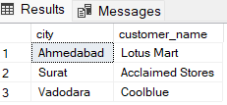

1. **Calculate Delivery-to-Order-Ratio of each Customer Name by City.**

WITH cte

AS (SELECT d.city,

d.customer_name,

f.order_qty,

f.delivery_qty

FROM [dbo].[dim_customers] AS d

LEFT JOIN [dbo].[fact_order_lines] AS f

ON d.customer_id = f.customer_id),

final

AS (SELECT city,

customer_name,

*Sum*(delivery_qty) AS total_delivery_qty,

*Sum*(order_qty) AS total_order_qty

FROM cte

GROUP BY city,

customer_name)

SELECT city,

customer_name,

**Concat**(*Round*(( *Cast*(total_delivery_qty AS *FLOAT*) /

*Cast*(total_order_qty AS *FLOAT*) ) *

100, 2), '%') AS delivery_to_order_ratio

FROM final

ORDER BY delivery_to_order_ratio DESC

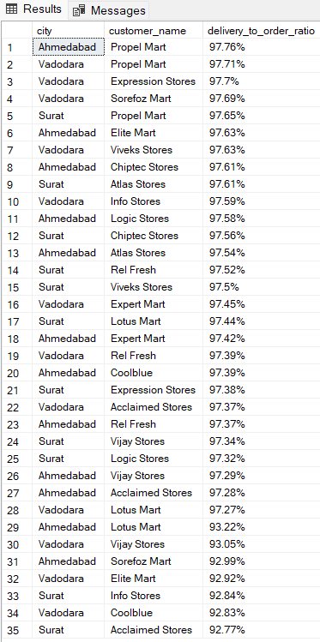

**--------------------------------Product Metrics------------------------------**

1. **Calculate the VOFR (volume fill rate) % of each Product Name.**

WITH cte

AS (SELECT d.product_name,

f.delivery_qty,

f.order_qty

FROM [dbo].[dim_products] AS d

LEFT JOIN [dbo].[fact_order_lines] AS f

ON d.product_id = f.product_id),

vofr_data

AS (SELECT C.product_name,

*Sum*(C.delivery_qty) AS total_delivery_qty,

*Sum*(C.order_qty) AS total_order_qty

FROM cte AS C

GROUP BY C.product_name)

SELECT product_name,

**Concat**(*Round*(*Cast*(total_delivery_qty AS *FLOAT*) / *Cast*(

total_order_qty AS *FLOAT*)

* 100,

2), '%') AS vofr_percentage

FROM vofr_data

WHERE total_order_qty <> 0 *-- Filter out rows where total_order_qty is zero*

ORDER BY vofr_percentage DESC

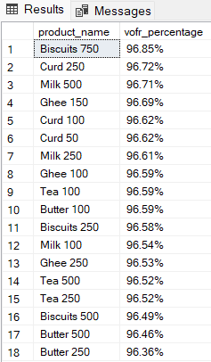

1. **Calculate the LIFR (line fill rate) % of each Product Name.**

WITH cte

AS (SELECT d.product_id,

d.product_name,

*Count*(*) AS total_order_lines,

*Sum*(CASE

WHEN f.in_full = 'Yes' THEN 1

ELSE 0

END) AS fulfilled_order_lines

FROM [dbo].[dim_products] AS d

LEFT JOIN [dbo].[fact_order_lines] AS f

ON d.product_id = f.product_id

GROUP BY d.product_id,

d.product_name)

SELECT product_name,

**Concat**(*Round*(( *Cast*(fulfilled_order_lines AS *FLOAT*) / *Cast*(

total_order_lines AS *FLOAT*)

) *

100.0, 2), '%') AS LIFR_percentage

FROM cte

WHERE fulfilled_order_lines > 0

*-- Filtering out rows where no order lines were fulfilled*

ORDER BY lifr_percentage DESC

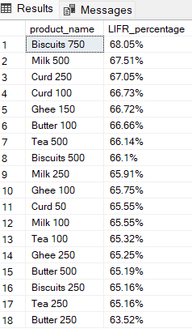

**--------------------------------Monthly Metrics-----------------------------**

1. **List of Customer Names with Highest Delivery Quantity for Each Month in Each City.**

WITH cte

AS (SELECT *

FROM [dbo].[dim_date] AS d

LEFT JOIN [dbo].[fact_order_lines] AS f

ON d.date = f.order_placement_date),

semi_data

AS (SELECT city,

customer_name,

**Format**(date, 'MM') AS year_month,

*Sum*(delivery_qty) AS total_delivery_qty

FROM [dbo].[dim_customers] AS d

INNER JOIN cte AS C

ON C.customer_id = d.customer_id

GROUP BY city,

**Format**(date, 'MM'),

customer_name),

ranked_data

AS (SELECT city,

year_month,

customer_name,

total_delivery_qty,

**Row_number**()

OVER(

partition BY city, year_month

ORDER BY total_delivery_qty DESC) AS rank

FROM semi_data)

SELECT city,

year_month,

customer_name,

total_delivery_qty

FROM ranked_data

WHERE rank = 1;

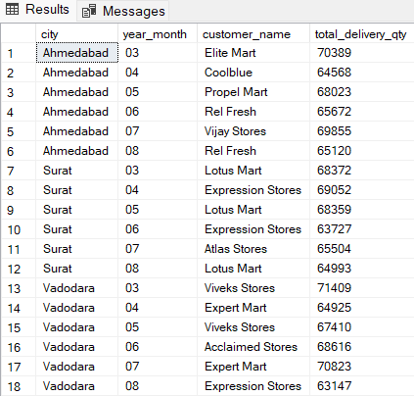

1. **List of Customer Names with Lowest Delivery Quantity for Each Month in Each City.**

WITH cte

AS (SELECT *

FROM [dbo].[dim_date] AS d

LEFT JOIN [dbo].[fact_order_lines] AS f

ON d.date = f.order_placement_date),

semi_data

AS (SELECT city,

customer_name,

**Format**(date, 'MM') AS year_month,

*Sum*(delivery_qty) AS total_delivery_qty

FROM [dbo].[dim_customers] AS d

INNER JOIN cte AS C

ON C.customer_id = d.customer_id

GROUP BY city,

**Format**(date, 'MM'),

customer_name),

ranked_data

AS (SELECT city,

year_month,

customer_name,

total_delivery_qty,

**Row_number**()

OVER(

partition BY city, year_month

ORDER BY total_delivery_qty ASC) AS rank

FROM semi_data)

SELECT city,

year_month,

customer_name,

total_delivery_qty

FROM ranked_data

WHERE rank = 1;

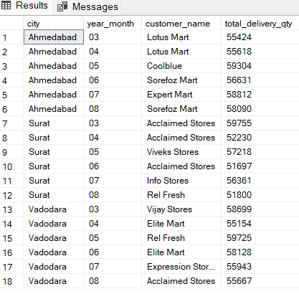

**------------------------------Customer Metrics-----------------------------**

1. **Calculate the OTIF % (On-time-in-full) % of each Product Name.**

WITH cte

AS (SELECT d.city,

d.customer_id,

dp.category,

d.customer_name,

dp.product_id,

dp.product_name,

f.order_qty,

f.delivery_qty,

f.in_full,

f.on_time,

f.otif

FROM [dbo].[dim_customers] AS d

LEFT JOIN [dbo].[fact_order_lines] AS f

ON d.customer_id = f.customer_id

RIGHT JOIN [dbo].[dim_products] AS dp

ON dp.product_id = f.product_id),

sec_cte

AS (SELECT *,

CASE

WHEN in_full = 'Yes'

AND on_time = 'Yes' THEN 1

ELSE 0

END AS otif_data

FROM cte)

SELECT customer_name,

**Concat**(*Round*(( ( *Cast*(*Sum*(otif_data) AS *FLOAT*) ) / ( *Cast*(

*Count*(customer_id) AS *FLOAT*)

) ) *

100.0, 2), '%') AS otif_percentage

FROM sec_cte

GROUP BY customer_name

ORDER BY otif_percentage DESC

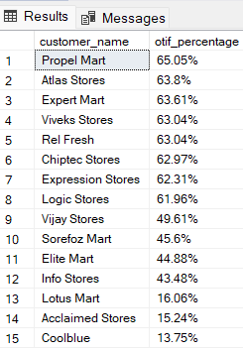

1. **List of Customer name with their in-full delivery percentage (%)?**

WITH cte

AS (SELECT d.customer_id,

d.customer_name,

CASE

WHEN in_full = 'Yes' THEN 1

ELSE 0

END AS in_full_detail

FROM [dbo].[dim_customers] AS d

LEFT JOIN [dbo].[fact_orders_aggregate] AS f

ON d.customer_id = f.customer_id)

SELECT customer_name,

Concat(*Round*(*Cast*(*Sum*(in_full_detail) AS *FLOAT*) / *Count*(*) * 100.0, 2),

'%') AS

in_full_percentage

FROM cte

GROUP BY customer_name

ORDER BY in_full_percentage DESC

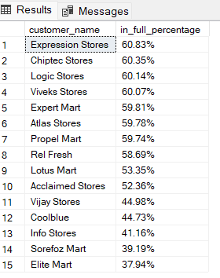

1. **List of Customer name with their on-time delivery percentage (%)?**

WITH cte

AS (SELECT d.customer_id,

d.customer_name,

CASE

WHEN on_time = 'Yes' THEN 1

ELSE 0

END AS on_time_detail

FROM [dbo].[dim_customers] AS d

LEFT JOIN [dbo].[fact_orders_aggregate] AS f

ON d.customer_id = f.customer_id)

SELECT customer_name,

**Concat**(*Round*(*Cast*(*Sum*(on_time_detail) AS *FLOAT*) / *Count*(*) * 100.0, 2),

'%') AS

on_time_percentage

FROM cte

GROUP BY customer_name

ORDER BY on_time_percentage DESC

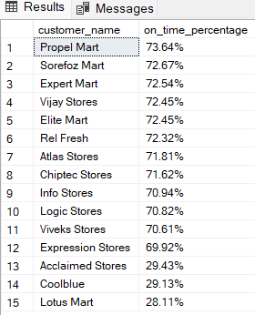

1. **List of Customer name with their otif percentage (%)?**

WITH cte

AS (SELECT d.customer_id,

d.customer_name,

CASE

WHEN otif = 'Yes' THEN 1

ELSE 0

END AS otif_detail

FROM [dbo].[dim_customers] AS d

LEFT JOIN [dbo].[fact_orders_aggregate] AS f

ON d.customer_id = f.customer_id)

SELECT customer_name,

**Concat**(*Round*(*Cast*(*Sum*(otif_detail) AS *FLOAT*) / *Count*(*) * 100.0, 2), '%')

AS

otif_percentage

FROM cte

GROUP BY customer_name ORDER BY otif_percentage DESC

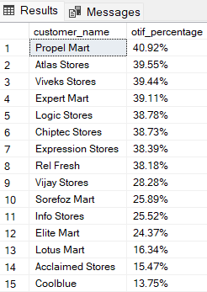

1. **List of Customer name with their LIFR percentage (%)?**

WITH cte

AS (SELECT d.customer_name,

*Count*(*) AS total_order_lines,

*Sum*(CASE

WHEN f.in_full = 'Yes' THEN 1

ELSE 0

END) AS fulfilled_order_lines

FROM [dbo].[dim_customers] AS d

LEFT JOIN [dbo].[fact_order_lines] AS f

ON d.customer_id = f.customer_id

GROUP BY d.customer_name)

SELECT customer_name,

**Concat**(*Round*(( *Cast*(fulfilled_order_lines AS *FLOAT*) / *Cast*(

total_order_lines AS *FLOAT*)

) *

100.0, 2), '%') AS LIFR_percentage

FROM cte

WHERE fulfilled_order_lines > 0

ORDER BY lifr_percentage DESC

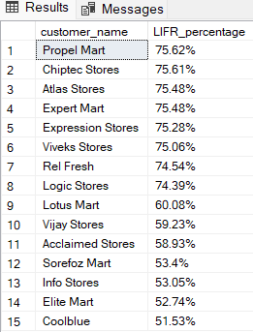

1. **List of Customer name with their Vofr percentage (%)?**

WITH cte

AS (SELECT d.customer_name,

f.delivery_qty,

f.order_qty

FROM [dbo].[dim_customers] AS d

LEFT JOIN [dbo].[fact_order_lines] AS f

ON d.customer_id = f.customer_id),

vofr_data

AS (SELECT C.customer_name,

*Sum*(C.delivery_qty) AS total_delivery_qty,

*Sum*(C.order_qty) AS total_order_qty

FROM cte AS C

GROUP BY C.customer_name)

SELECT customer_name,

**Concat**(*Round*(*Cast*(total_delivery_qty AS *FLOAT*) / *Cast*(

total_order_qty AS *FLOAT*)

* 100,

2), '%') AS vofr_percentage

FROM vofr_data

WHERE total_order_qty <> 0 *-- Filter out rows where total_order_qty is zero*

ORDER BY vofr_percentage DESC

